

Automated Toll Collection System

OBJECT ORIENTED PROGRAMMING 2

Section: N

**GUIDED BY**

Aymed Hossain

Department of Computer Science

American International University-Bangladesh

**PREPARED BY**

|  |  |  |  |
| --- | --- | --- | --- |
| **NO** | **NAME** | **ID** | |
| 1. | MAHMUD, SULTAN | | 16-32712-3 | |
| 2. | RAHMAN, SHOJIBUR | | 18-36205-1 | |
| 3. | SHAMS-E-TAMANNA | | 18-36551-1 | |
| 4. | ISLAM,SAIFUL | | 18-37404-1 | |

# Introduction:

The automated toll collection system will work as a prepaid toll payment system which will save a lot of time since vehicles passing through the toll plaza won’t have to stop to pay the toll anymore. Our country's toll collection system, is one of the sole reasons for the traffic jam on highways and we hope to offer a solution for this problem via this project.

# User Category:

There are two types of Users here. They are:

* Admin
* User

# Feature List:

In this project the “Admin” has the following features:

* Introducing different toll packages
* Managing those toll packages
* Checking reports of all toll transactions
* Checking existing user lists

In this project the “User” has the following features:

* Profile Creation
* Adding unlimited vehicles
* Managing existing vehicles
* Checking self-transaction history
* Checking all available toll places and their fares
* Paying the toll before crossing the gate

# ER Diagram

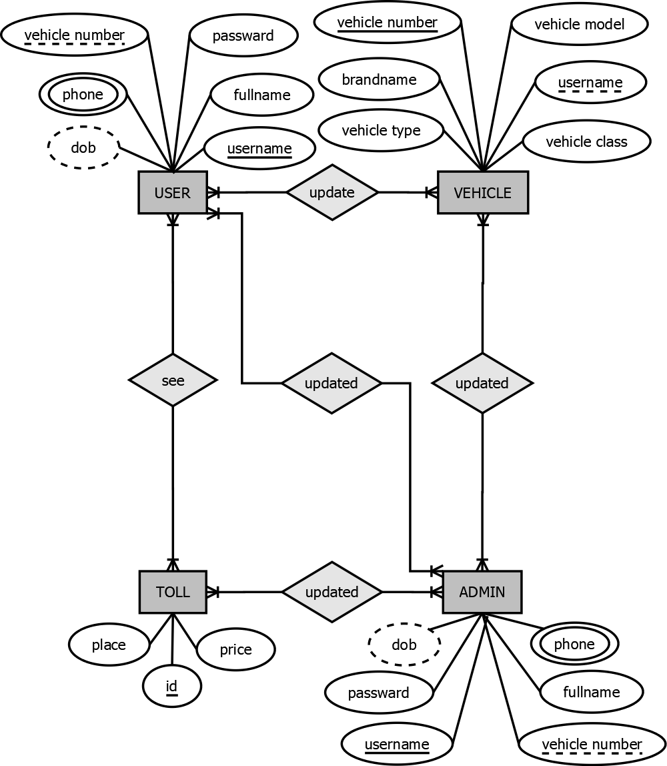

# Class Diagram

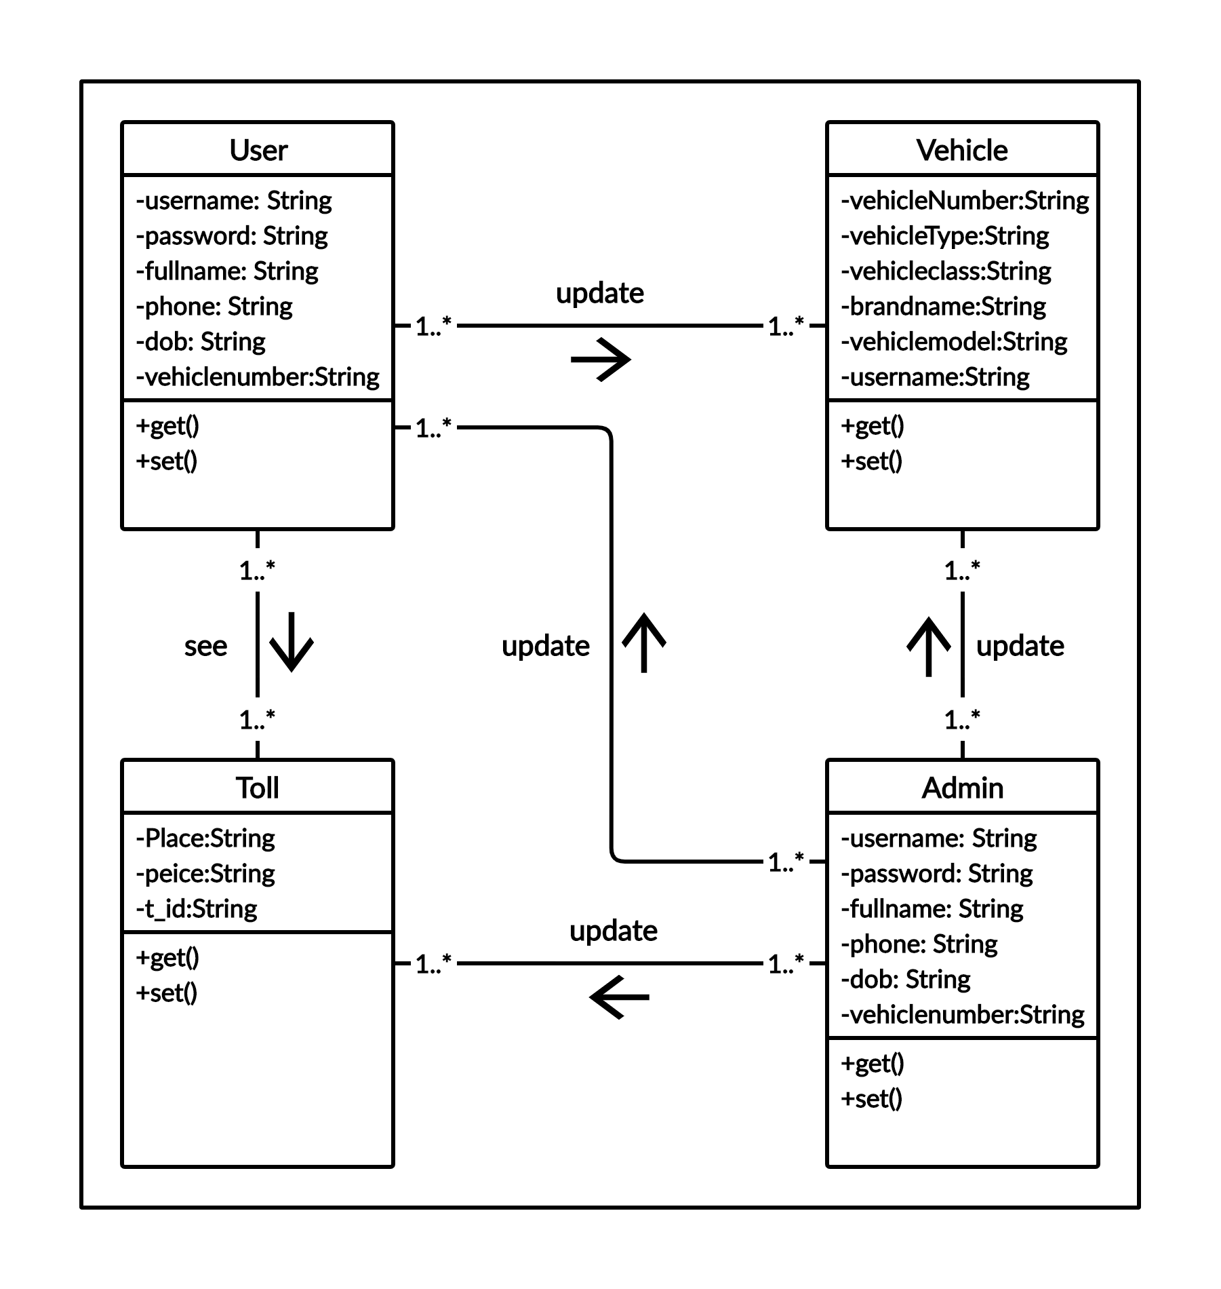

# Use Case Diagram

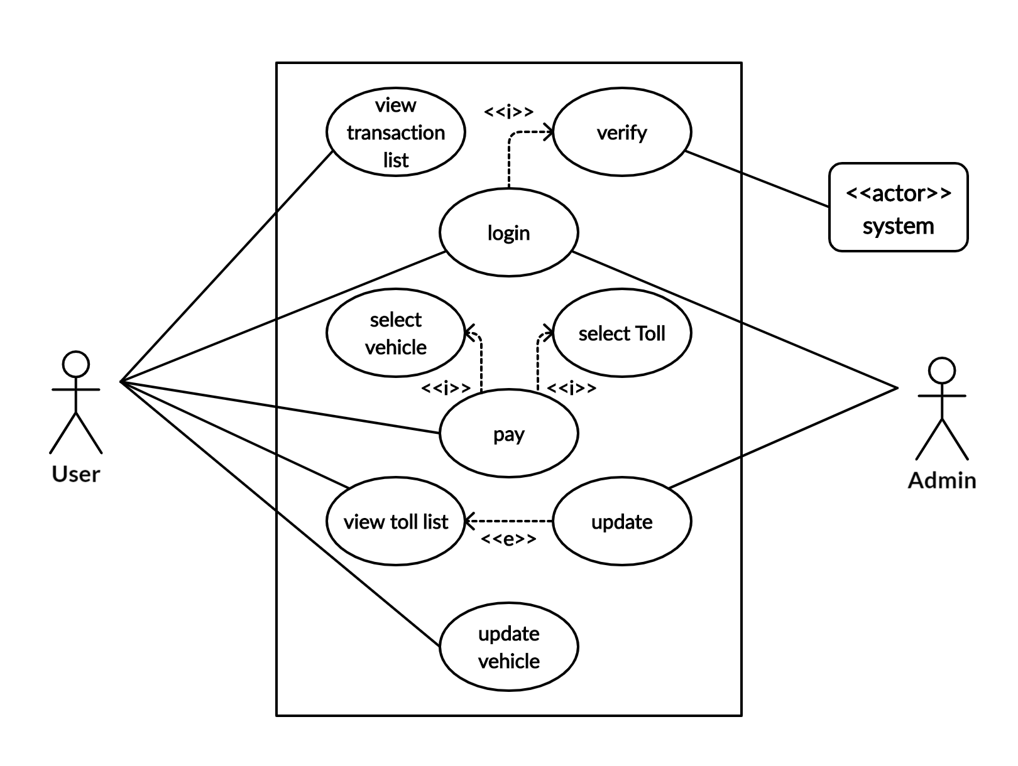

# Activity Diagram:

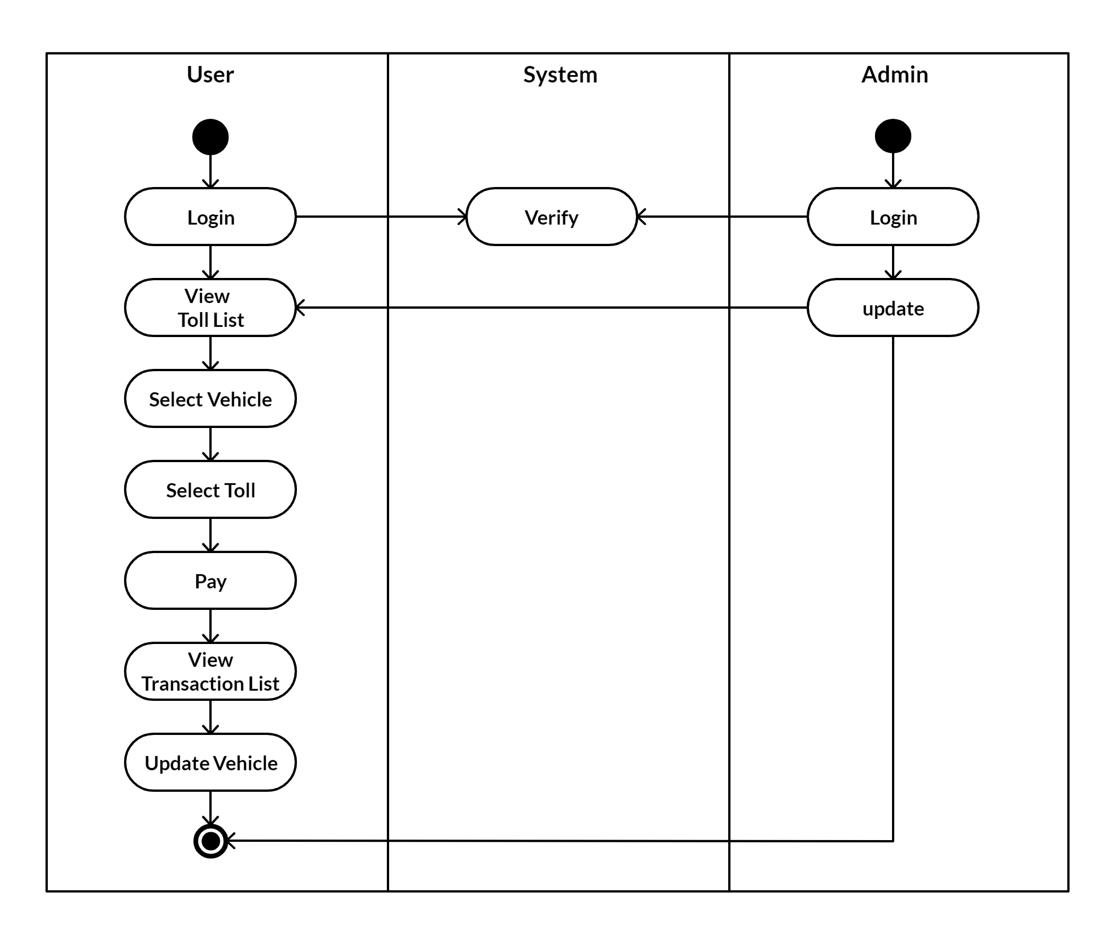

# Table Creation

## User:

CREATE TABLE `user` (

`username` varchar(30) NOT NULL,

`password` varchar(30) NOT NULL,

`fullname` varchar(30) NOT NULL,

`phone` varchar(15) NOT NULL,

`dob` varchar(30) DEFAULT NULL,

`vehiclenumber` varchar(20) DEFAULT NULL,

`admin` int(11) NOT NULL DEFAULT 0

);

ALTER TABLE `user`

ADD PRIMARY KEY (`username`),

ADD UNIQUE KEY `username` (`username`);

## Toll

CREATE TABLE `toll` (

`place` varchar(50) NOT NULL,

`price` int(20) NOT NULL,

`t_id` int(10) NOT NULL

);ALTER TABLE `toll` ADD PRIMARY KEY (`t_id`);

## Vehicle

CREATE TABLE `vehicle` (

`brandname` varchar(30) NOT NULL,

`vehiclemodel` varchar(40) NOT NULL,

`vehiclenumber` varchar(20) NOT NULL,

`vehicleclass` varchar(40) NOT NULL,

`vehicletype` varchar(30) DEFAULT NULL,

`username` varchar(30) DEFAULT NULL

); ALTER TABLE `vehicle` ADD PRIMARY KEY (`vehiclenumber`),

ADD UNIQUE KEY `vehiclenumber` (`vehiclenumber`, `username`),

ADD FOREIGN KEY (`username`) REFERENCES `user` (`username`);

## Transaction

CREATE TABLE `transaction` (

`id` int(11) NOT NULL,

`placeName` varchar(30) DEFAULT NULL,

`amount` int(20) NOT NULL,

`vehiclenumber` varchar(30) DEFAULT NULL,

`date` varchar(30) NOT NULL,

`username` varchar(30) NOT NULL

); ALTER TABLE `transaction` ADD PRIMARY KEY (`id`);